**IMPORTANCE OF DATA VISUALIZATION**

Simplifies complex data to make decisions

**GETTING STARTED WITH TABLEAU**

1. **Connecting tables through server**

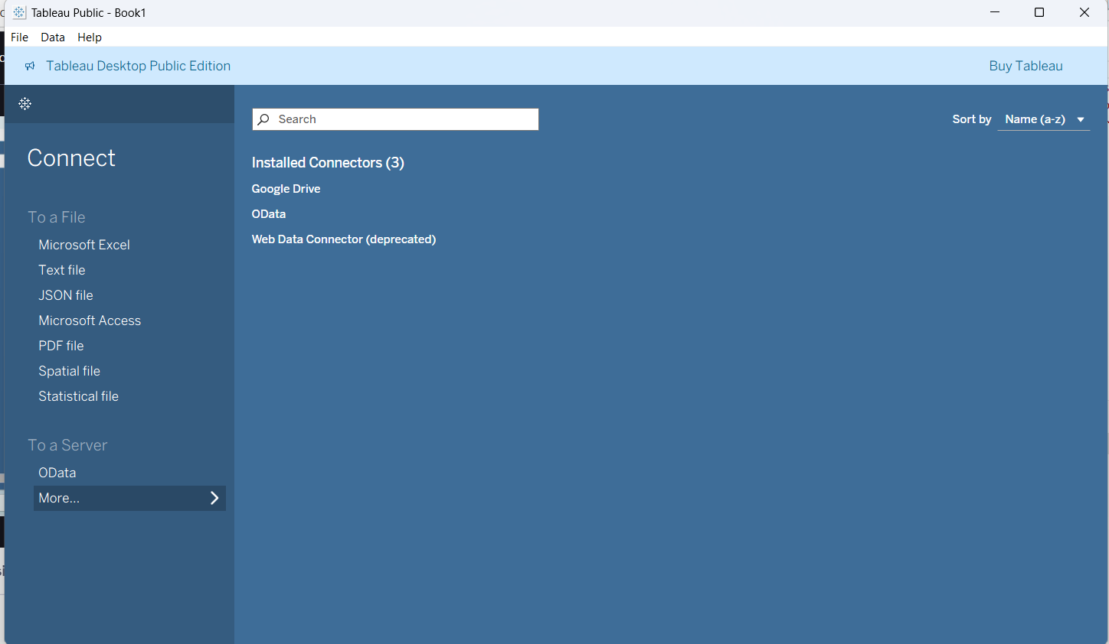

In above image more option we can find the options to take data from any existing relational

database servers.

1. **Loading excel sheet –** It can be done using To a file option, after loading it below is the screen, in row we can enter how many rows we want to load all data.

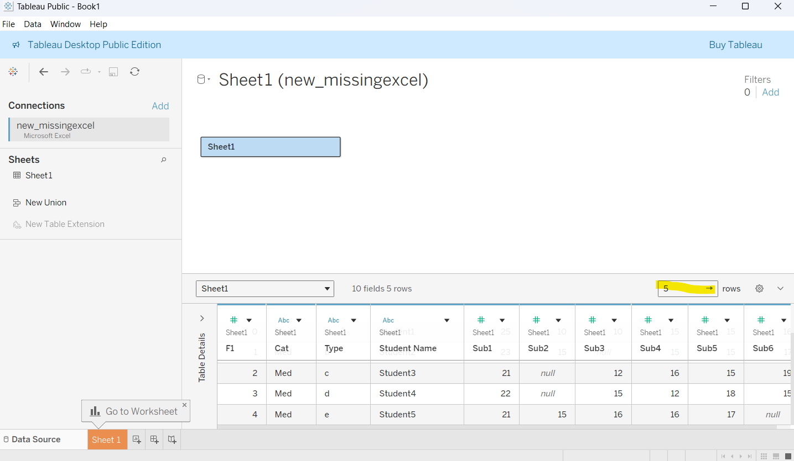

1. **Cleaning text file in work sheet –** when we load excel, csv files there a option called use data interpreter will be available that will cleans the excel sheet before loading the excel sheet into tableau.

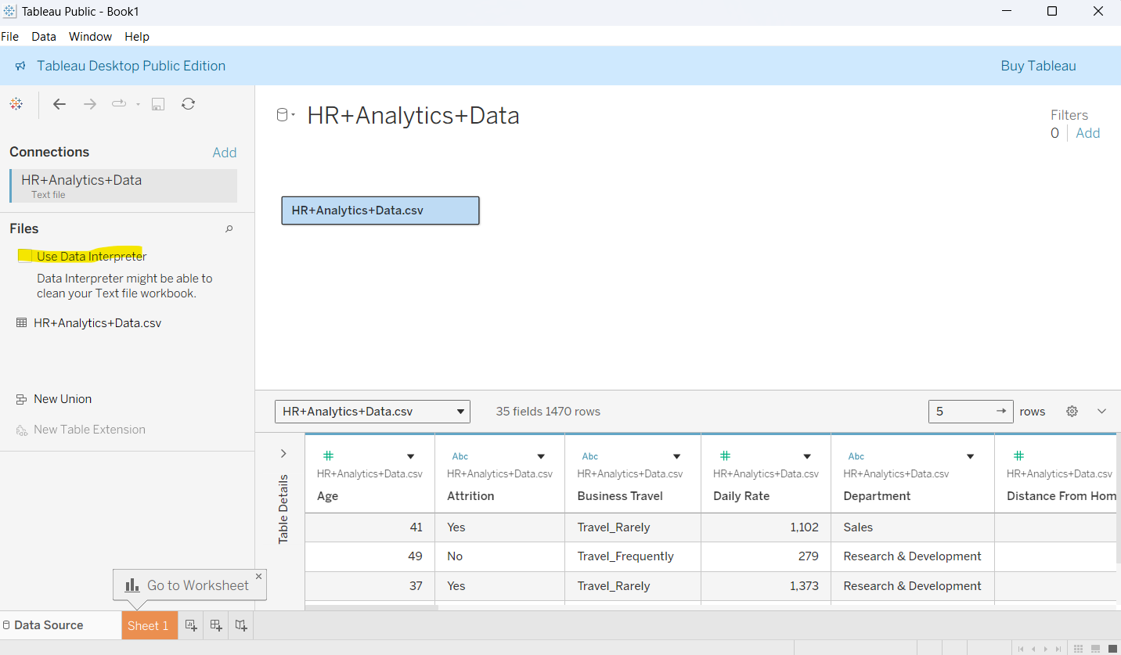

**Example:**

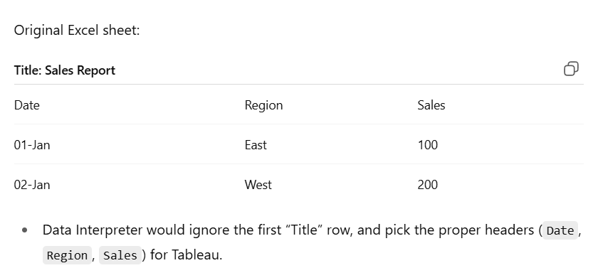

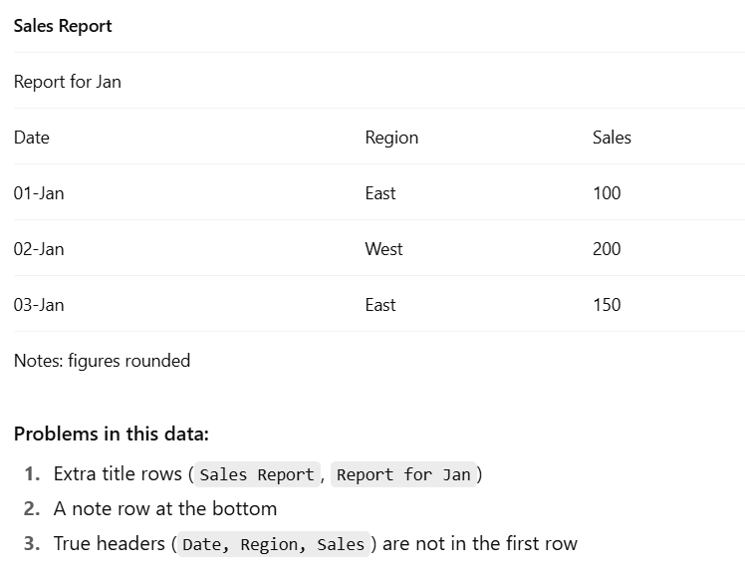

1. **Automatic generated fields –** When we load a excel file tableau has a feature to create new columns from it, in below dataset we have location so, longitude, latitude will be generated from it automatically.

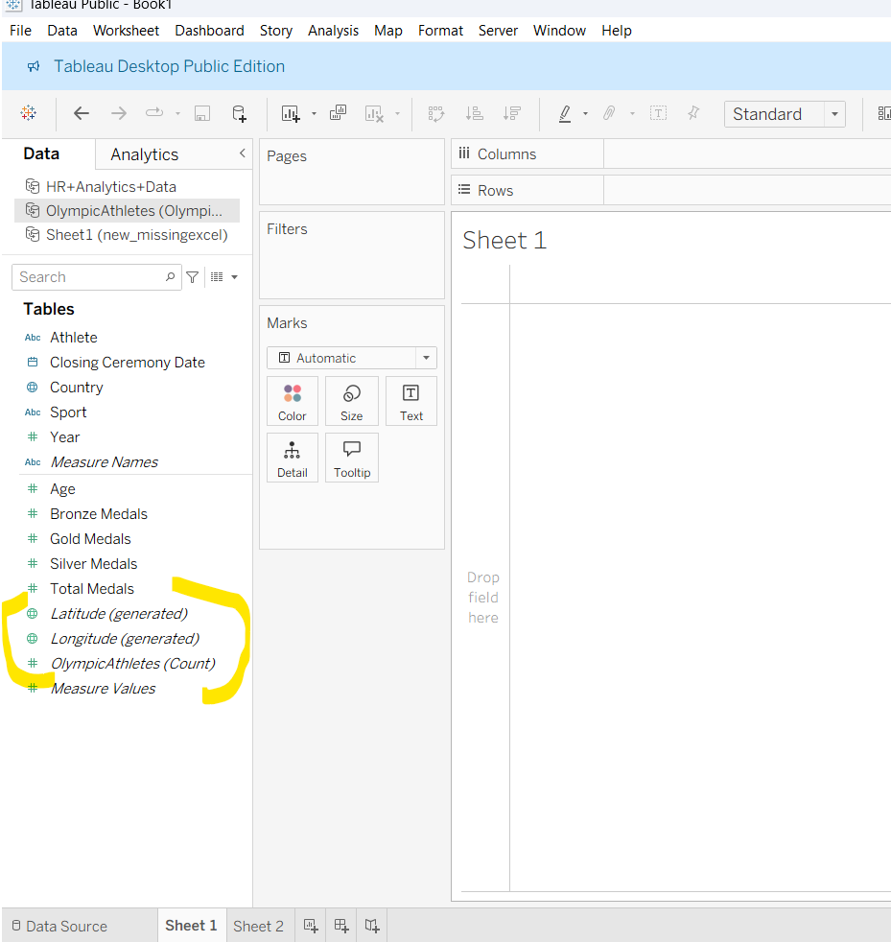

**CREATE SAMPLE DASHBOARD**

1. Load the excel sheet
2. Move to sheet option
3. Double on sheet to give title like below a pop will open. Give title click ok or apply

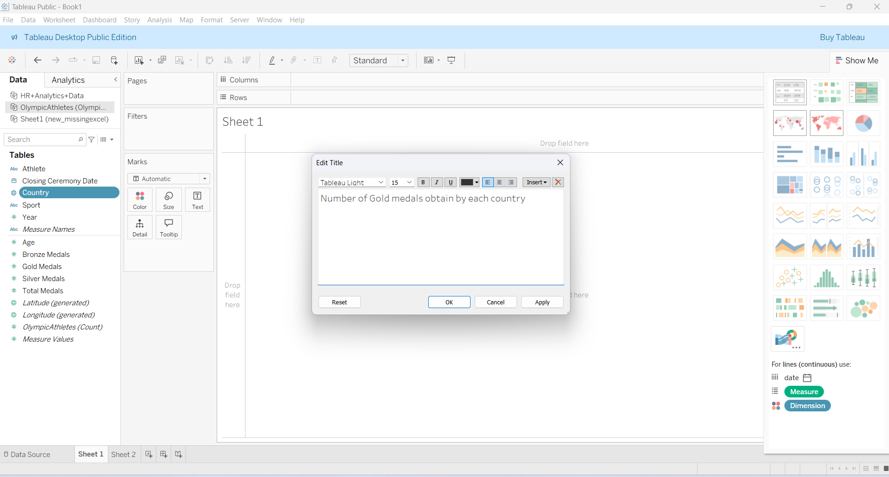

1. Drag and drop the needed columns and rows from left side to center columns like below image.

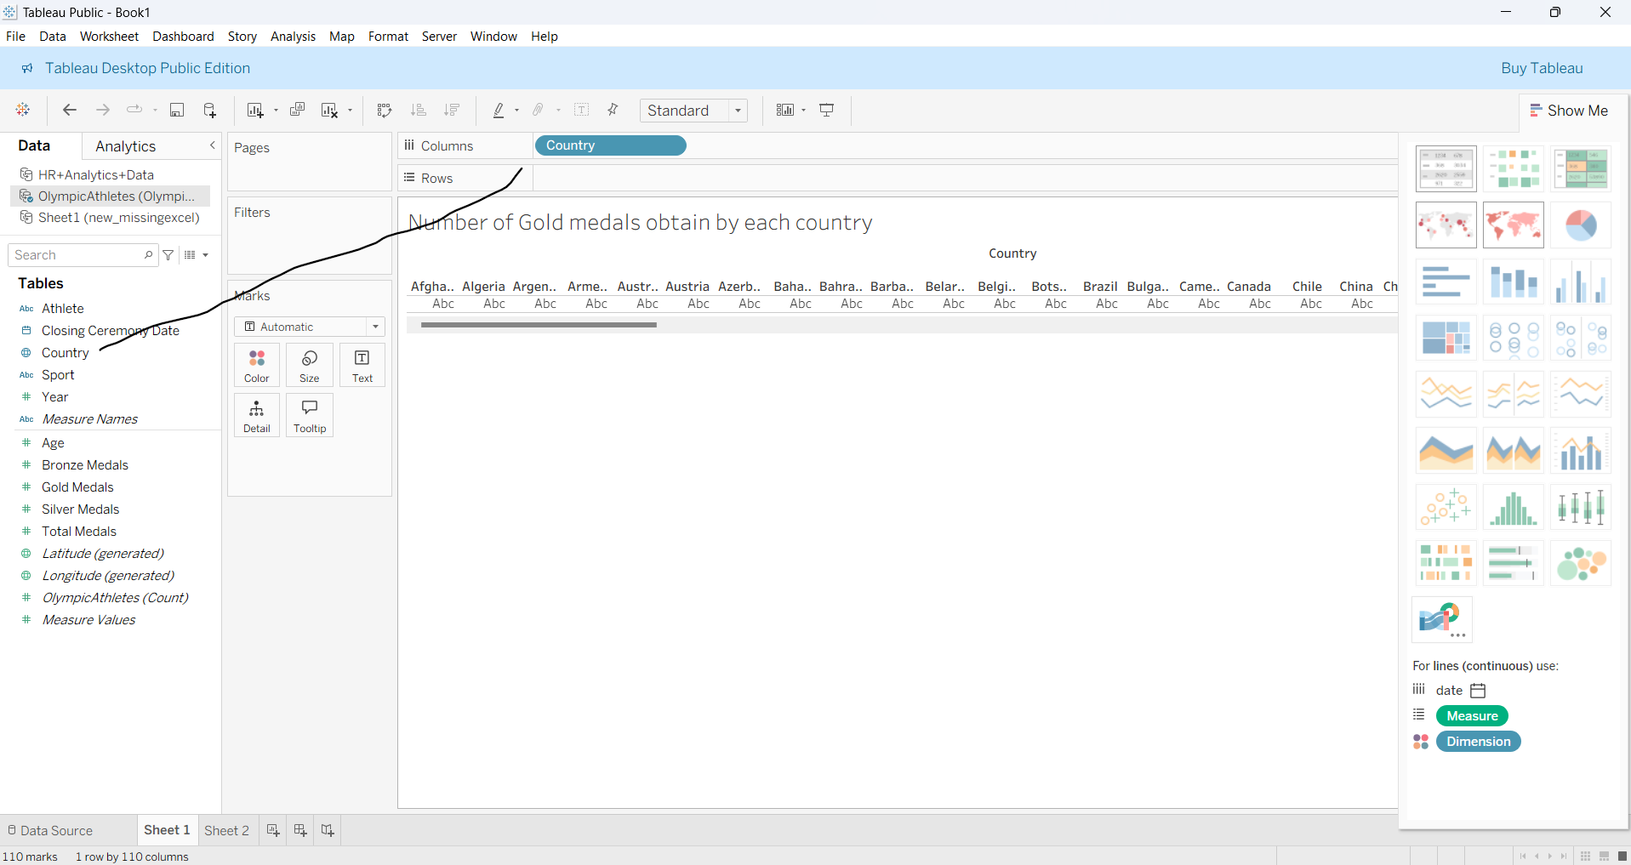

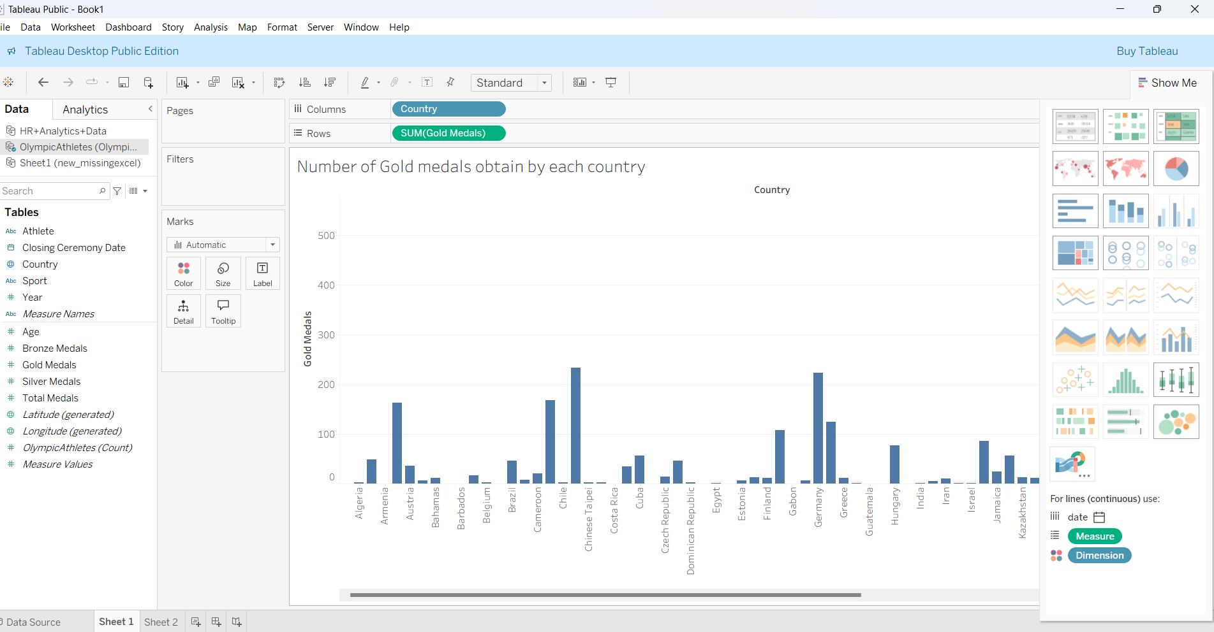

We can change any type of charts from the right corner charts

**ADDING DIFFERENT COLORS TO EACH BAR**

If we drag and drop the column we want into color then each bar will take different color like below.

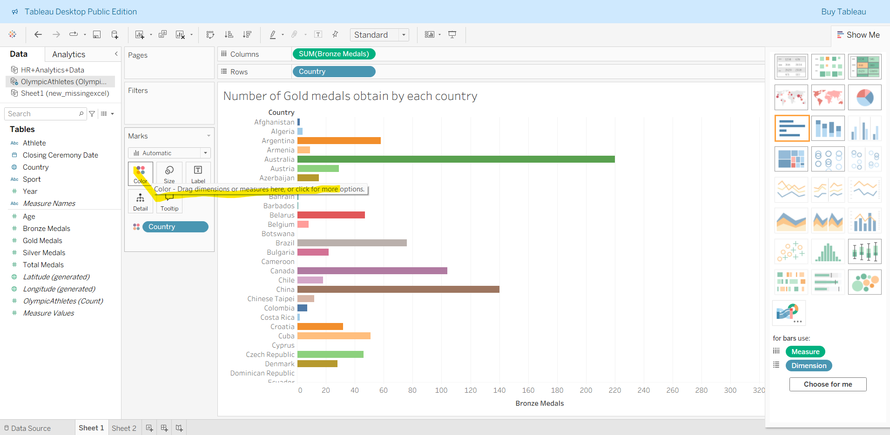

**TAKE TABLE INSTEAD OF GRAPH**

From the table option in right side we can convert our graph into table like below

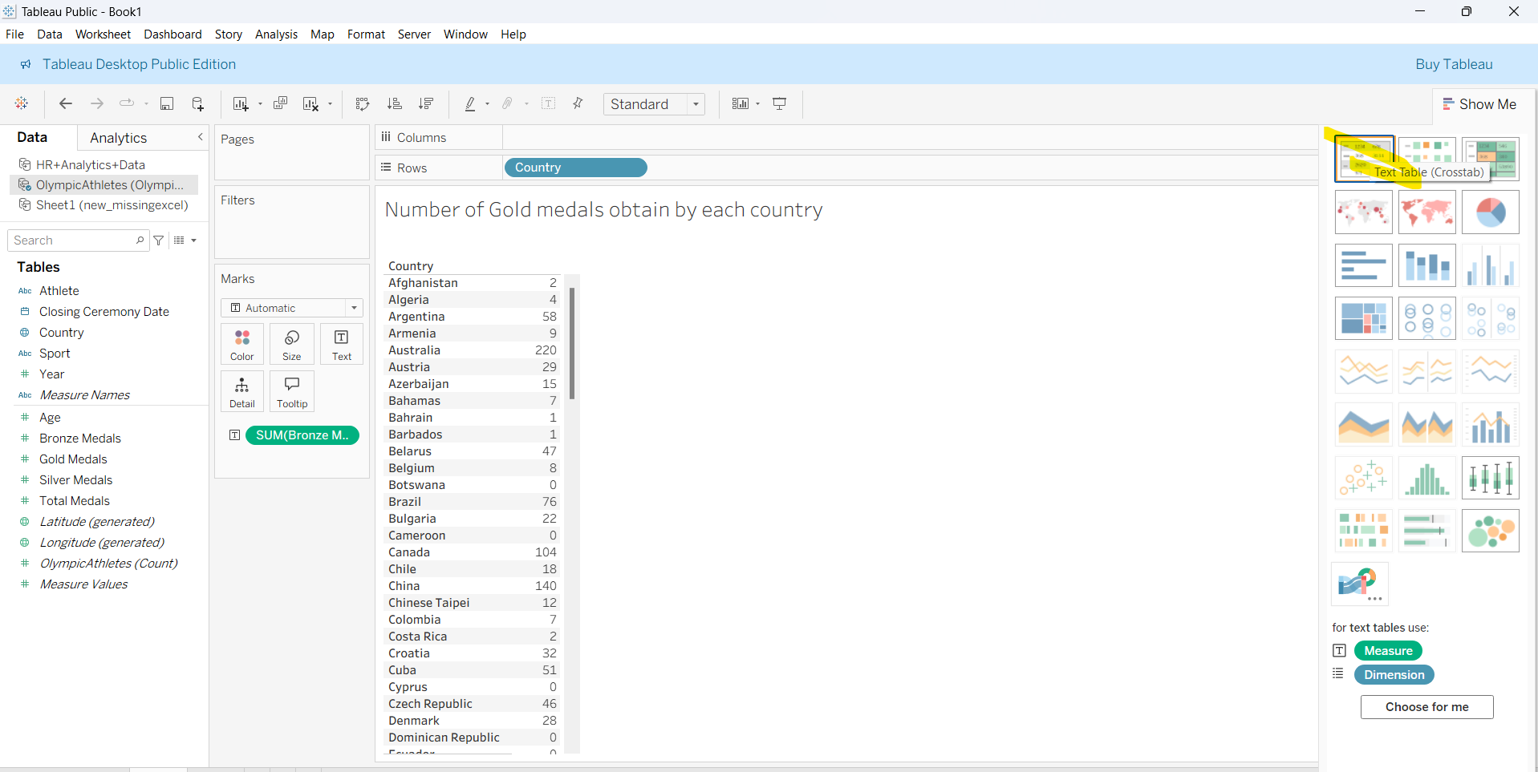

**FORMATING HEADING**

Like adding bg color to heading can be done by the below options

